

**California Polytechnic State University Pomona**

DEPARTMENT OF ELECTRICAL & COMPUTER ENGINEERING

IINTRO TO MICROCONTROLLERS LAB

ECE 3301L.03

**LAB 11 – I2C Bus Implementation**

Prepared by

**Kelly Williams**

**and**

**Isaac Bernal**

Presented to

Felix Pinai

November 14, 2024

# TABLE OF CONTENTS

TABLE OF CONTENTS 2

INTRODUCTION 3

Objective 3

Summary 3

DATA AND RESULTS 3

CONCLUSION 3

# INTRODUCTION

## Objective

This lab will introduce students to the I2C communication protocol, allowing them to use different sensors in circuits to measure things like temperature, in this case. Students will also use a real-time clock (RTC) for the first time and learn how to reset the time to be accurate. Combined with work done in previous labs on interrupts, students will create a system that reads the temperature from the sensor every second and outputs the value along with the time from the RTC. When a specific button is pressed, students will use interrupts to make the system reset the RTC to a predetermined value. This lab serves mainly as an introduction to I2C and how addresses can be read as sensor data.

## Summary

For hardware, the main new component is the I2C sensor. The rest of the build is primarily the same as the previous lab so students can focus on troubleshooting the new component. For software, the code is also build from the previous lab along with some guidance in the lab manual to implement the I2C protocol to read sensor data. Software students will view the I2C address protocol with the Logic Analyzer to view the waveforms and troubleshoot the circuit. They will also initialize a real-time clock to display the time along with the sensor output in Tera Term. Using the interrupt protocol from the previous labs, students will press the EQ button on the remote to reset the RTC. However, software students must make sure the time is only reset with the EQ button and not any other remote entry, adding to the challenge of this lab. It is also important for software students to note the speed of their logic analyzer, otherwise the waveform output will be inaccurate, and the addresses will not make any sense.

# DATA AND RESULTS

Part 1:

Temp displayed in Tera Term:

Logic Analyzer output:

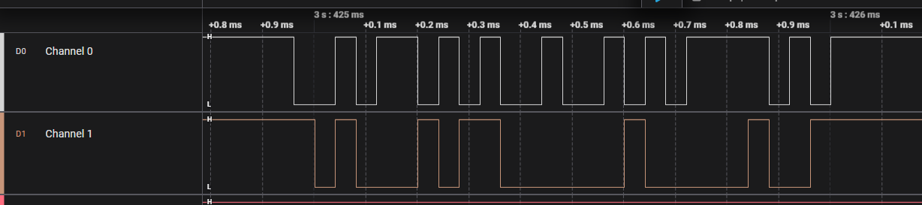

Speed was too low here, but it gets fixed before the end of the lab. This was a good troubleshooting opportunity for software students.

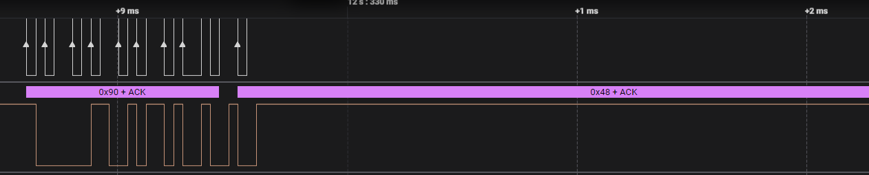

Part 2:

Temperature output to Tera Term with real-time clock (RTC):

Tera Term output with RTC updated to current time:

EQ button pressed to reset time to 7:15pm:

Logic Analyzer output:

Pressing buttons other than EQ does not reset time:

When button location a8 is pressed, the time continues without resetting. When location 90 is pressed (EQ button), the time resets to 7:15pm.

# CONCLUSION

This lab allowed students to learn how to use I2C sensors and understand the communication protocol to troubleshoot the output if things go wrong. By using the Logic Analyzer to view the waveforms, students can read the addresses being read and written to and see if it matches what was specified in the code to ensure the circuit and code is working as intended. By using much of the same hardware configuration and code functions, students were able to focus on the new elements of the I2C sensor and real-time clock.